

CLASSIC WATCH

## A PROJECT REPORT

SUBMITTED IN PARTIAL FULFILLMENT OF THE REQUIREMENT FOR THE AWARD OF THE DEGREE OF.

## BECHOLER OF COMPUTER APPLICATION TO

RK UNIVERSITY, RAJKOT

SUBMITTED BY

### Name of Student Enrollment No.

DHRUVIN KOTHARI 19FOTCA11044

VIRAJ KOTHARI 19FOTCA11045

## UNDER THE GUIDANCE OF

Prof.Homera Durani Dr.Nirav Bhatt

Assistant Professor, Professor ( HOD ),

RK University, RK University,

Rajkot. Rajkot.

**Signature of Faculty:**

Dhruvin Kothari Viraj Kothari

Date : \_\_\_\_\_\_\_ Place :\_\_\_\_\_\_\_ Date : \_\_\_\_\_\_\_ Place :\_\_\_\_\_\_\_

Table of Contents

|  |  |  |
| --- | --- | --- |
| **Sr No:** | **Subject Name :** | **Page No :** |
| 1. | Introduction | 3 |
| 2. | Modules | 5 |
| 3. | Project Planning & Analysis | 6 |
| 4. | DFD’S & Flow Chart | 8 |
| 5. | System Design | 16 |
| 6. | Screen Shot & Coding | 17 |
| 7. | Admin Panel | 27 |
| 8. | Software Testing | 38 |
| 9. | Summary & Conclusion | 41 |

**(1) Introduction**

### Introduction

* + - Classic watch is an online selling website in which buyer could buy a wrist watch online
    - This site could help customers to buy a new watch easily.
    - User can buy a watch by category like Analog watch, Digital watch, Hybrid watch, Touch screen watch.
    - Also user can buy a watch by Watch Style Causal watch, Dress watch, Fashion watch, luxury watch.
    - User can buy a watch based on movement like Quartz, Mechanical Automatic and Solar.
    - Online watch buying website is very easy to access and users could save the time and he/she can access website everywhere.
    - User is no need to visit a watch shop/store. Sometime watch shop is close but users can shop 24x7 using our website. The online system is available to use anytime
    - They just need internet and smart device like Smartphone and laptop etc.
* User is no need to visit a watch shop/store. Sometime watch shop is close but users can shop 24x7 using our website. The online system is available to use anytime.
* They just need internet and smart device like Smartphone and laptop etc.

**(2) Modules**

**MODULES OF CLASSIC WATCH**

* Admin Profile : admin can see all the products, add a new product, change the price of product and also delete old products. Admin give discount on product.
* Customer profile : customer can see various products ,buy a product , add product into cart ,delete from cart and they can have many types of payment gateway.
* Log in / create new account : user can log in in our website or they can create a new account.
* Payment Gatway: user can do three way to payment in our website like

Cash On Delivery, Credit Card and Debit Card.

**(3) Project Planning & Analysis**

PROJECT PLANNING

Project Title : Classic Watch Online Selling

Starting Date : 20-06-2021

Ending Date : 24-03-2022

### Project Scheduling

* The toughest part of software development can be said to Planning and scheduling. This project has many features like add, update, delete a watch.
* Scheduling of the project implies the adequate resources are available or not. Each small task of the project is scheduled by time, person and many other factors. Gantt chart is a type of bar chart. Here, the Gantt chart for various activities to develop a project is described.

### Software requirement specifications (SRS)

#### Functional Requirements:

##### System Requirements (Hardware, Software)

The requirements for development and implementation of this application are categorized into following categories.

##### Hardware Requirements

* **Client side:**

|  |  |  |
| --- | --- | --- |
| Category | Requirement |  |
| Device | Android supported | |

* **Developer side:**

|  |  |  |
| --- | --- | --- |
| Category | Requirement |  |
| RAM | 256 MB | |
| Space on disk | Minimum 256MB | |

* **User side:**

|  |  |
| --- | --- |
| Category | Requirement |
| Chrome | Our project support any chrome version |

* **Developer side:**

|  |  |
| --- | --- |
| Category | Requirement |
| OS | Windows / Linux |
| Technologies used | Php , html ,css |

**(4) DFD’S & Flow Chart**

#### DFD:-

#### ZERO Level Diagram:-

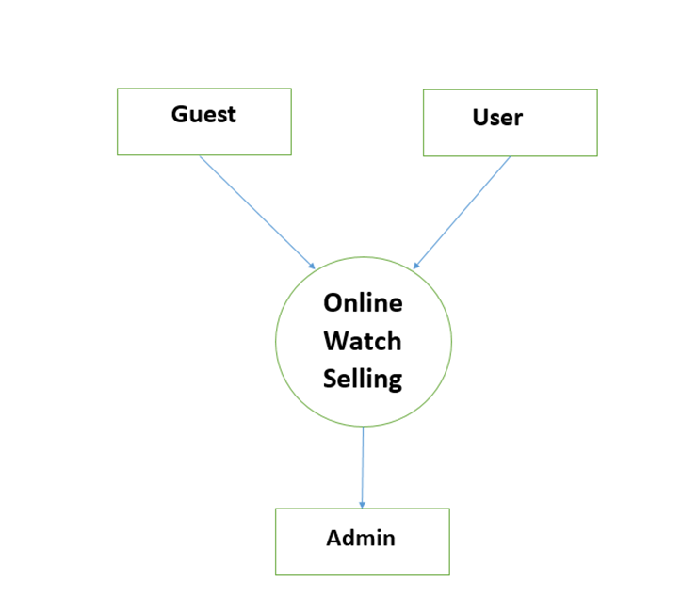

#### First Level Diagram:-

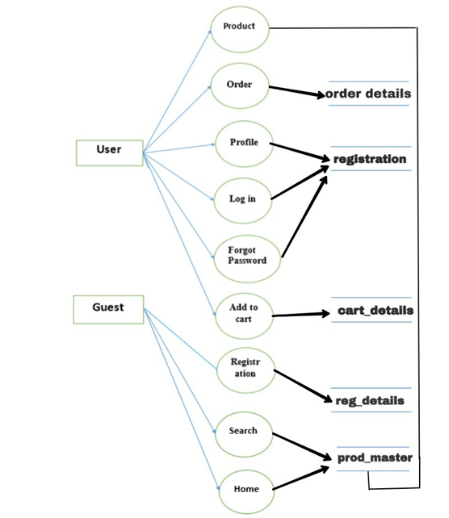

#### Second Level Diagram:-

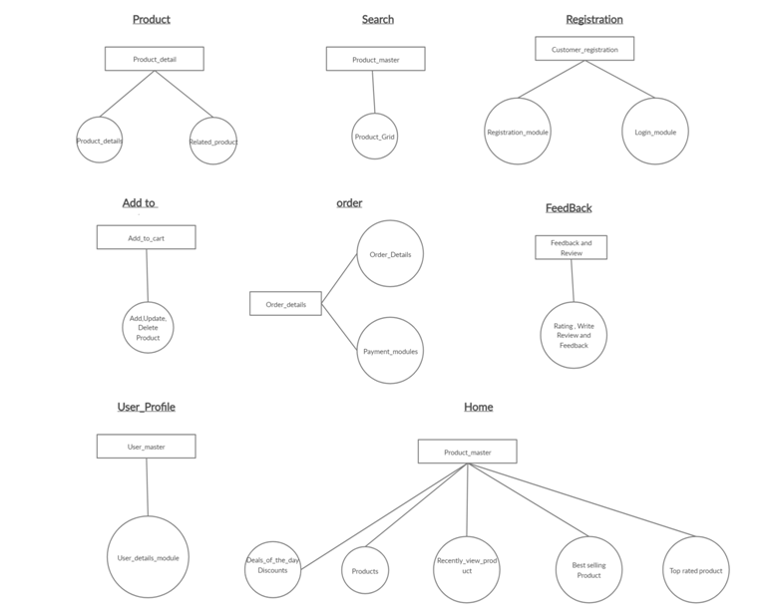

#### Use Case Diagram :-

#### H:\project_5th\use_case_diagram.jpg

#### Admin Activity:-

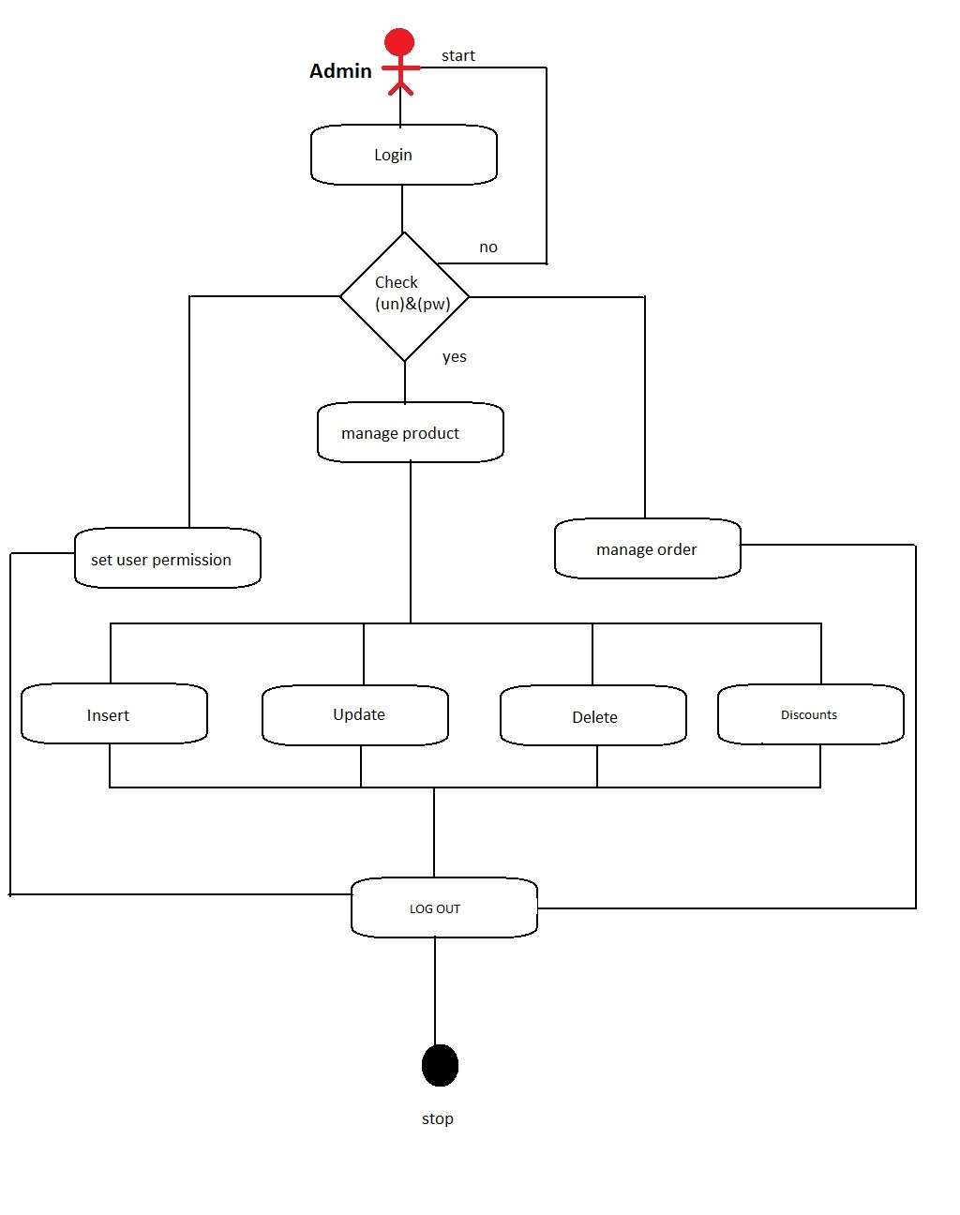

#### Guest Log In :-

#### guest_login.jpg

#### Guest Activity :-

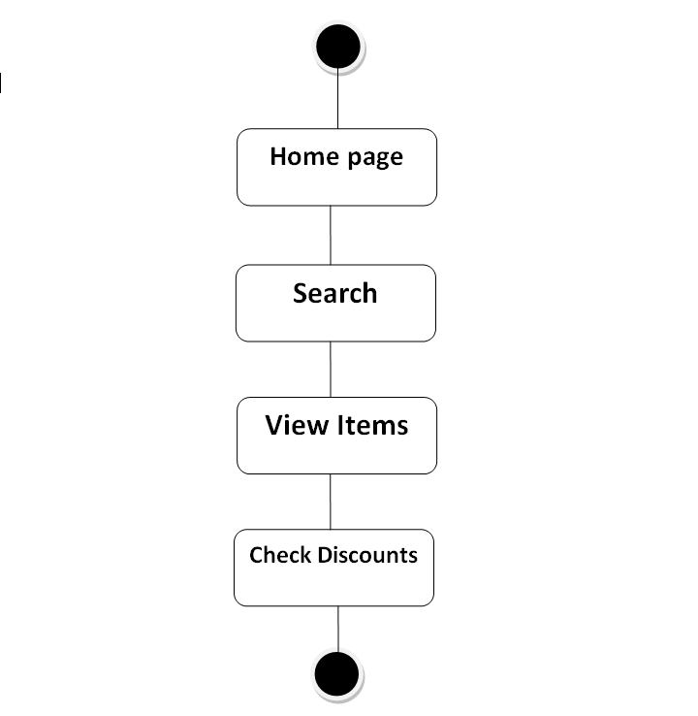

#### E R Diagram:-

#### E R diagram.jpg

**(5) System Design**

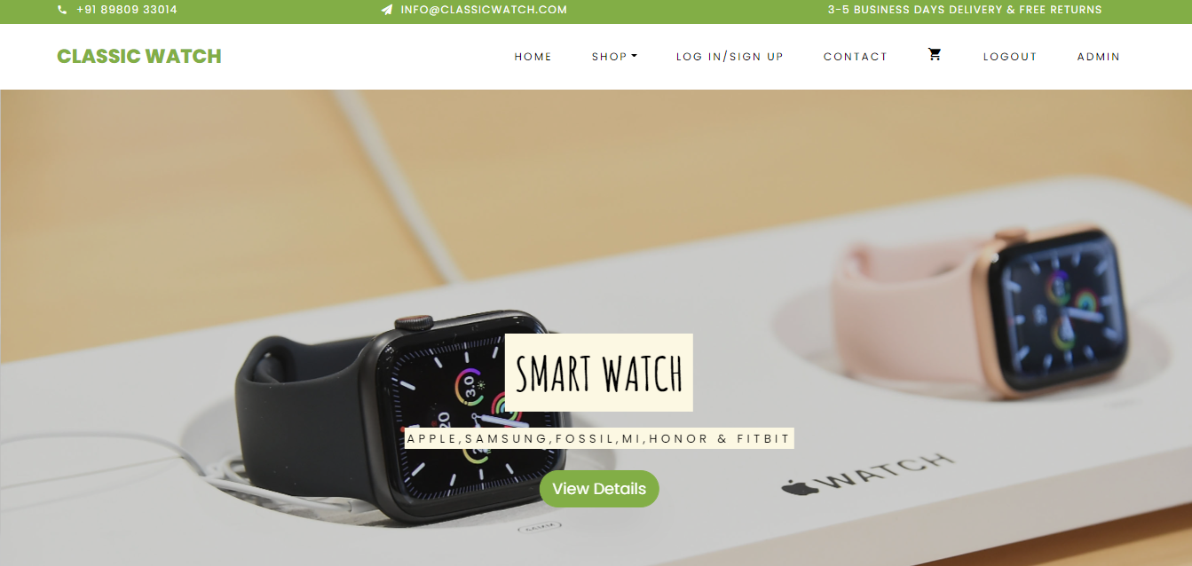

### Introduction:-

* + - Systems design is the process of defining the architecture, components, modules, interfaces, and data for a system to satisfy specified requirements.

### Logical Design:-

* + - The logical design of a system pertains to an abstract representation of the data flows, inputs and outputs of the system.
    - In the context of systems design are included. Logical design includes Zero level ,First level diagram and Use case Diagrams.

**(6) Screen Shot & Coding**

# LOG IN PAGE:

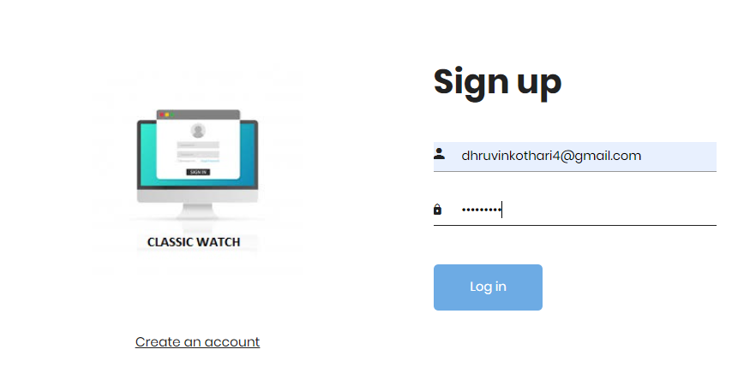

##### Description :

* There are many types of features available in our CLASSIC WATCH WEBSITE
* User can see different types of watch categories like Smart Watch, Automatic Watch, Smart Band,Steel Belt Watch, Premium Watch, Leather Watch.To see any type of watch go to that category.

# SIGN UP PAGE :

# 

* **CATEGORY OF WATCH :**

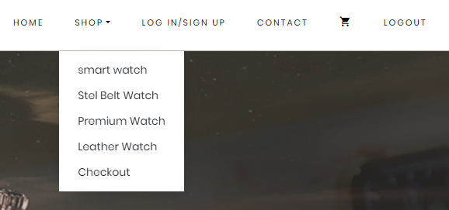

##### CATEGORYY.PNG

##### Description :

In our Website , you can see many types of categories in watch

# ADD_TO_CART.PNG

# PAYMENT GATEWAY:

# 1.Cash On delivery:

# 

# 

# 2- Debit Card:

# 

# 3. Credit Card:

# 

# Order Summary:

# 

**(7) Admin Panel**

# ADMIN PANEL :

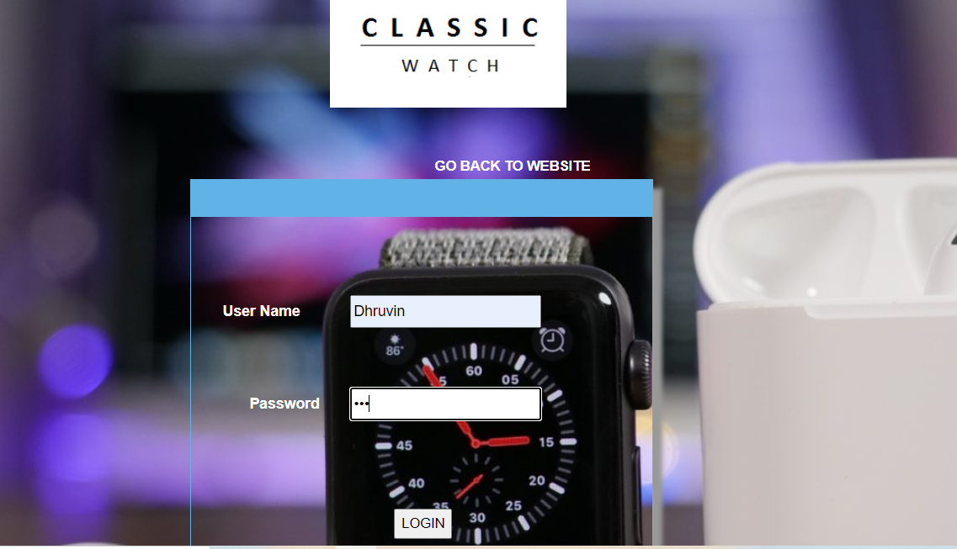

# 

# 

# ADD PRODUCT :

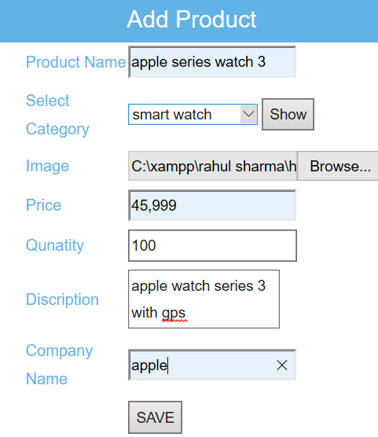

* **ADD CATEGORY :**

# C:\Users\HP\Pictures\Screenshots\Screenshot (106).png

##### DELETE PRODUCT :

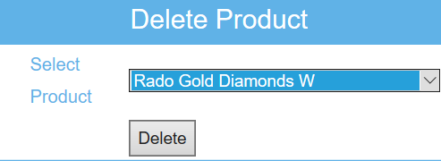

* **DELETE CATEGORY :**

# C:\Users\HP\Pictures\Screenshots\Screenshot (108).png

# UPDATE PRODUCT :

# C:\Users\HP\Pictures\Screenshots\Screenshot (110).png

* **UPDATE CATEGORY:**

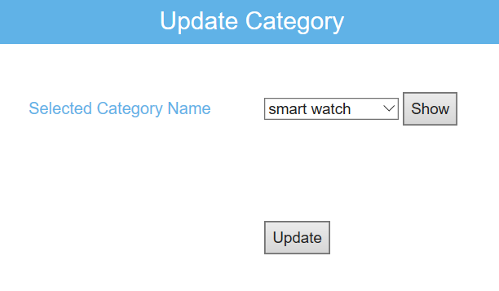

# VIEW PRODUCT WITH DETAILS :

# VIEW_PRODUCTS.PNG

# VIEW ORDER :

# 

# VIEW CART WITH DETAILS :

# VIEW_CART.PNGVIEW CUSTEMER DETAILS:

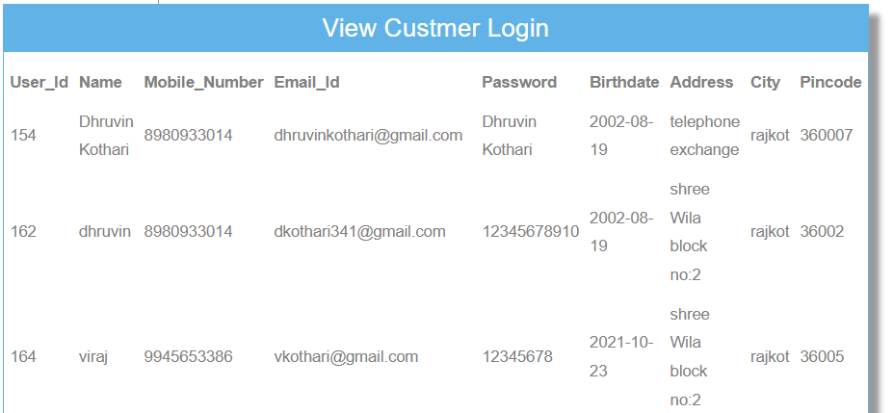

**(8) Project Testing**

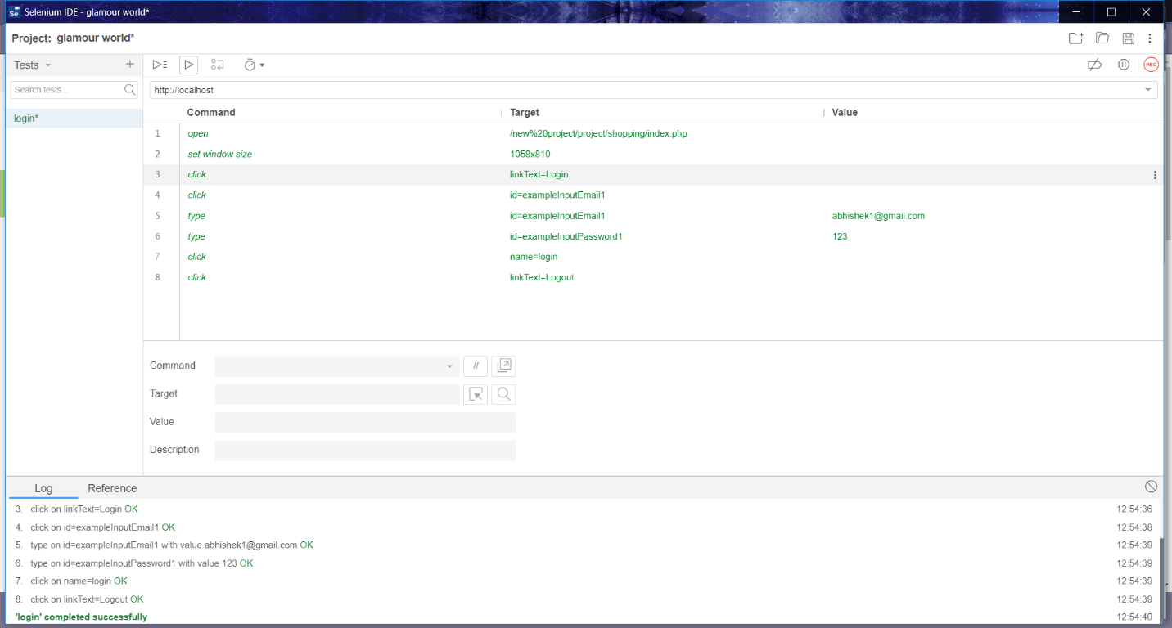

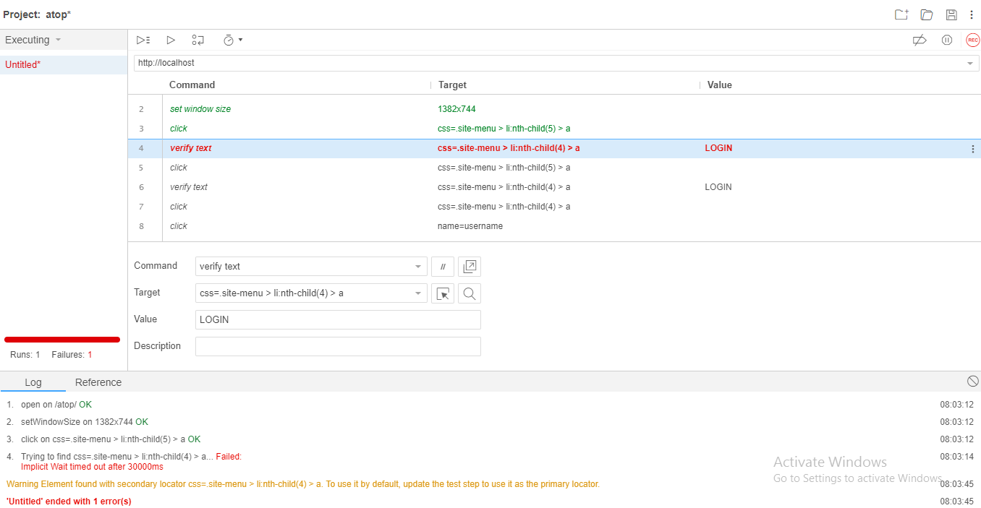

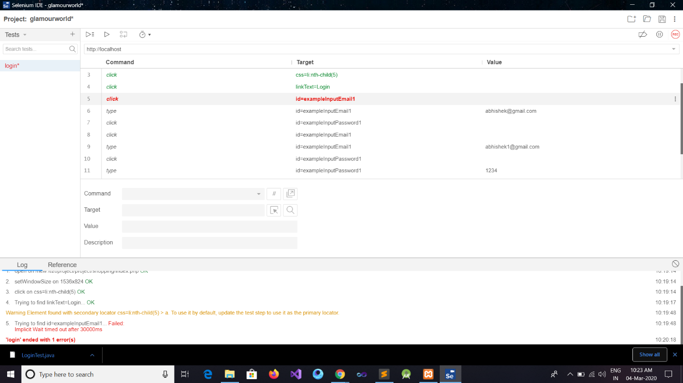

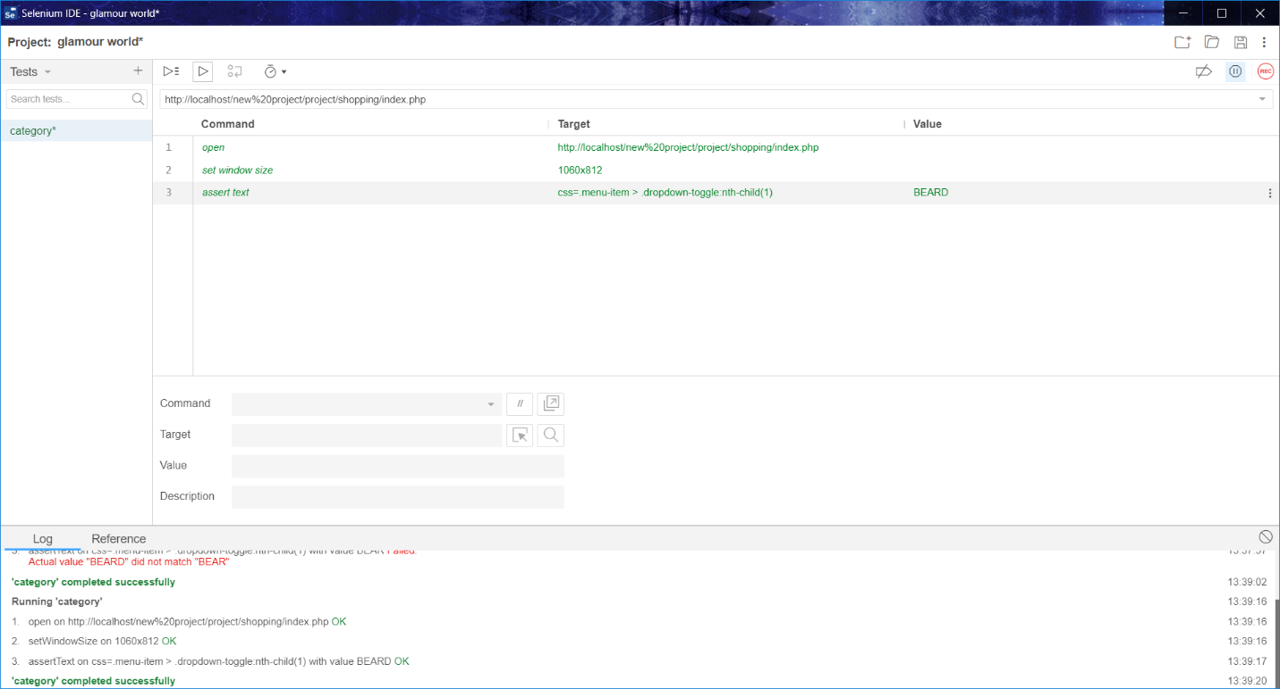

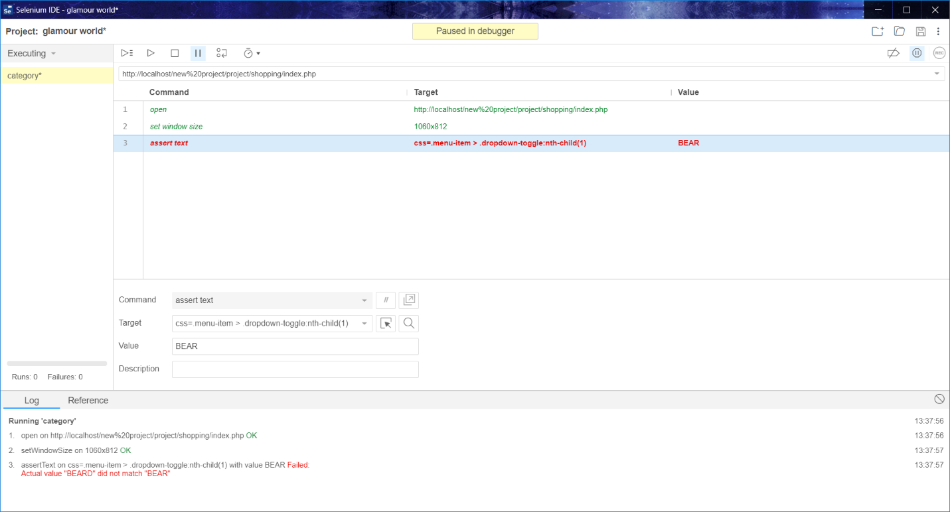

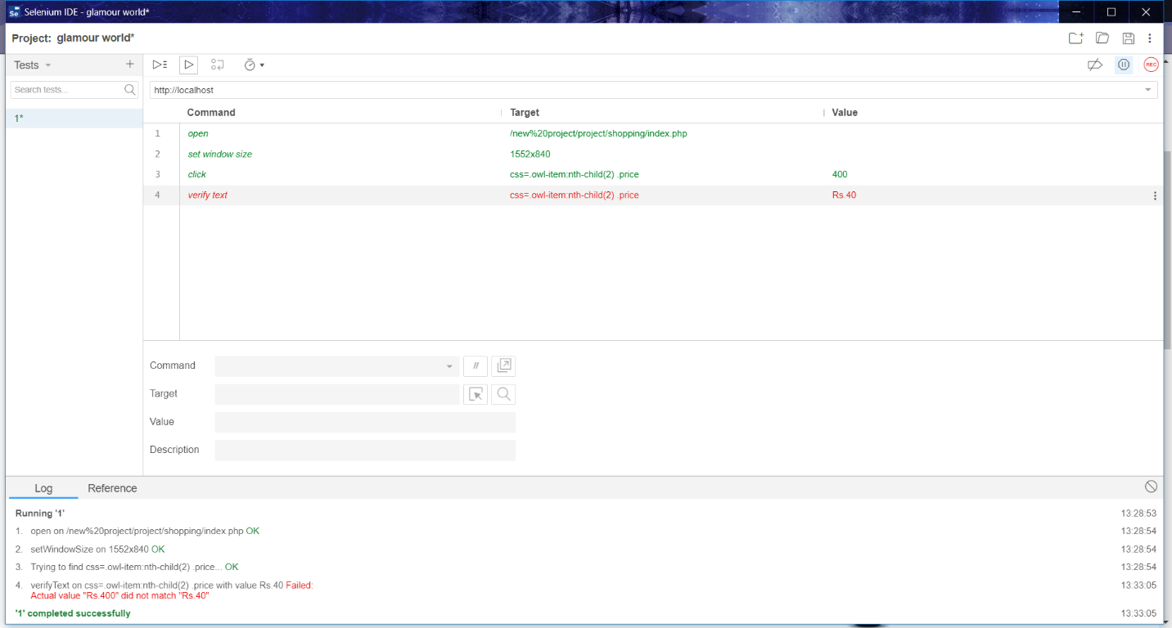

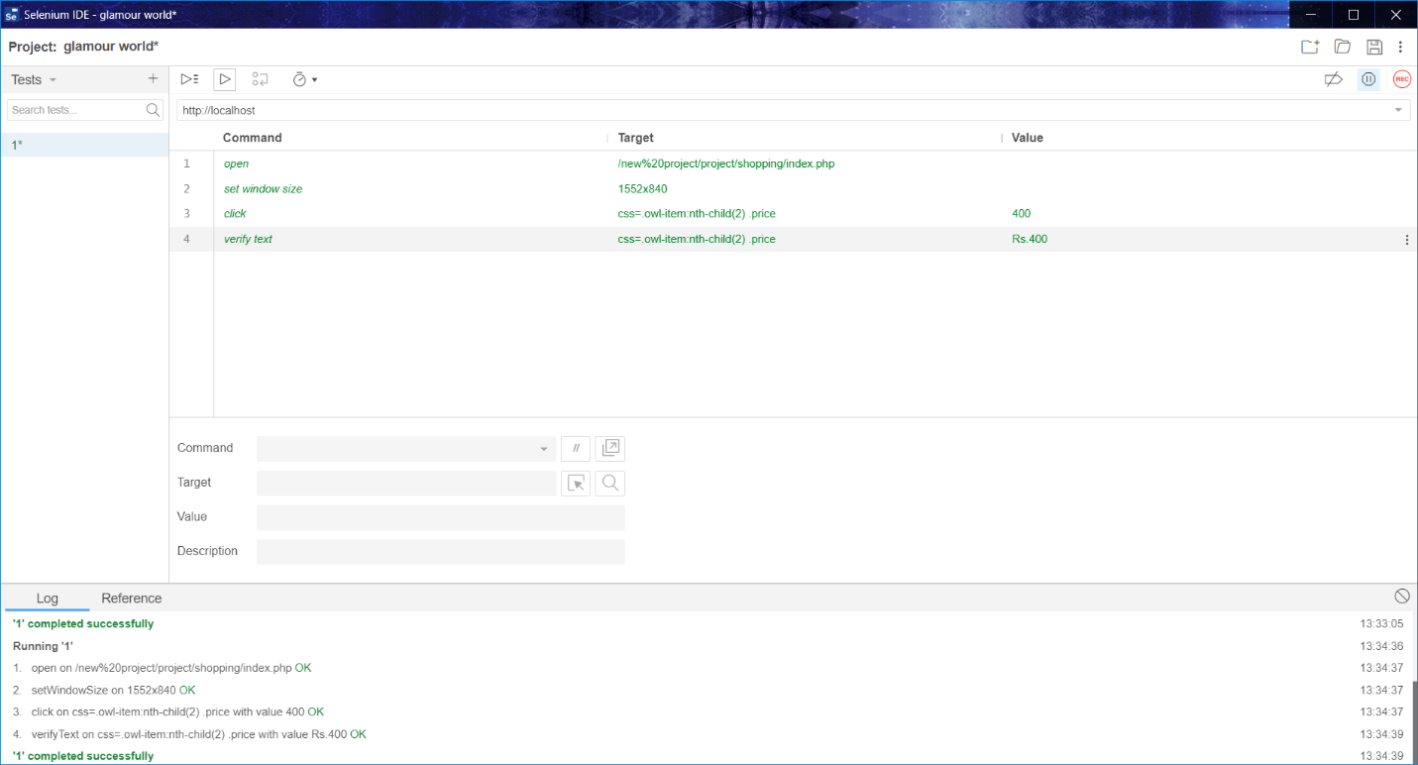

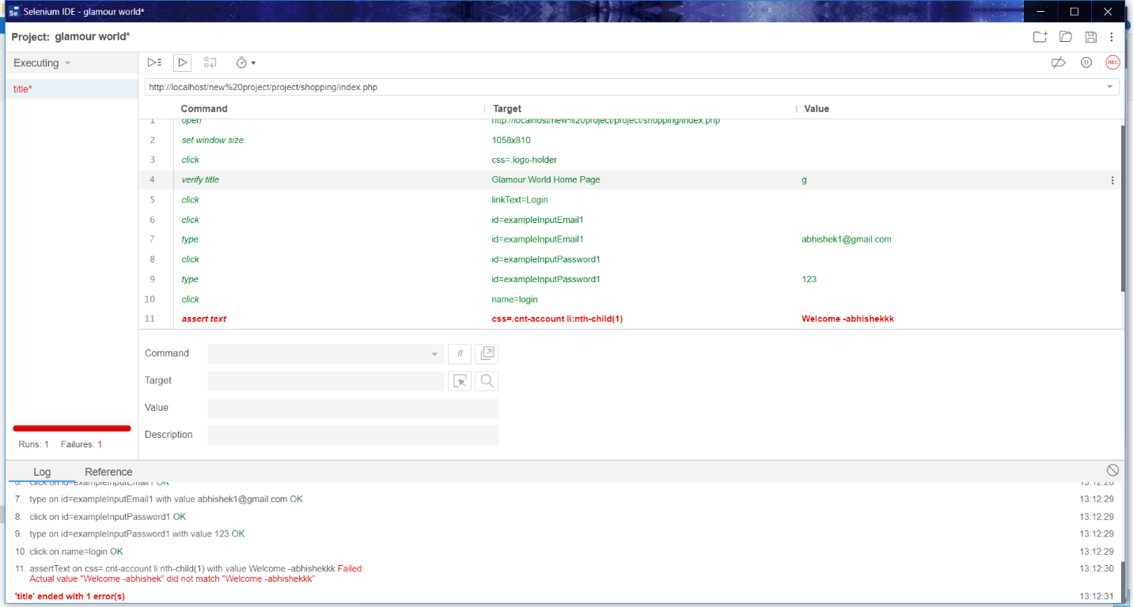



* **8.1 TESTING METHODS :-**

There are different methods which can be used for Software testing. This

chapter briefly describes those methods.

**1) Black Box Testing: -**

Black box testing, also called behavioral testing, focuses on the functional

requirements of software. This testing approach enables the software engineer to

derive the input conditions that will fully exercise all requirements for a

program. Black box testing attempts to find the errors. You don't need to know

the internal design in detail or have a good knowledge about the code for this

test.

**2) White Box Testing: -**

White box testing is also called Glass box testing is a test case design control;

structure of the procedural design to derive test cases using White box testing

method, the software engineer can derive the test cases that guarantee that all

independent paths within the module have been exercised at least once. This test

is based on detailed know ledged of the internal design and code.

* **DATABASE CONNECTIVITY:**
* **Admin\_Login\_Table:**

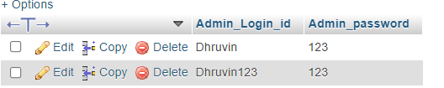

* **Cart:**

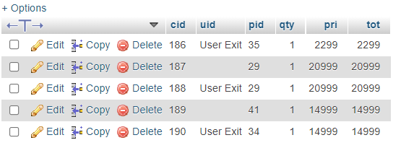

* **Categories\_Types:**

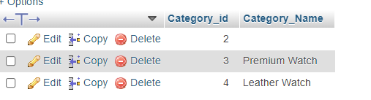

* **Contact\_Table:**

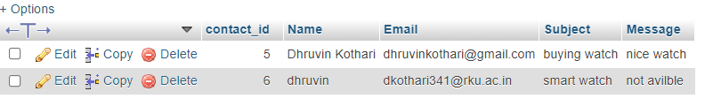

* **Debit\_Card:**

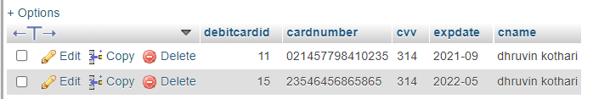

* **OrderSummary:**

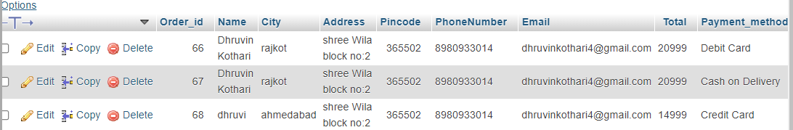

* **Product\_Table:**

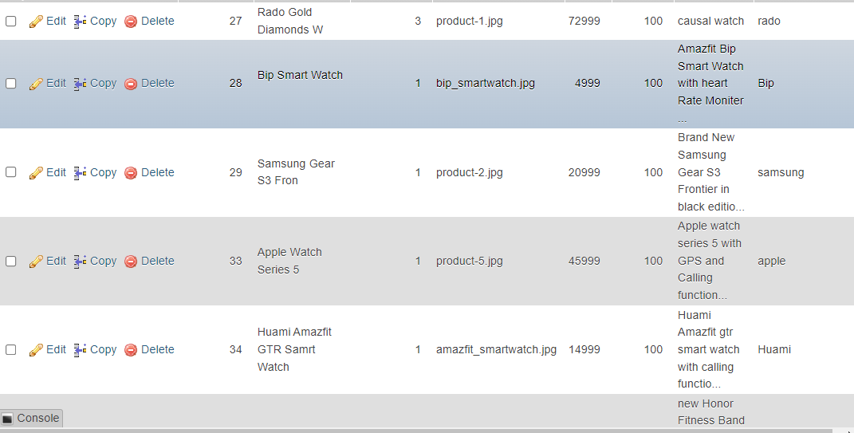

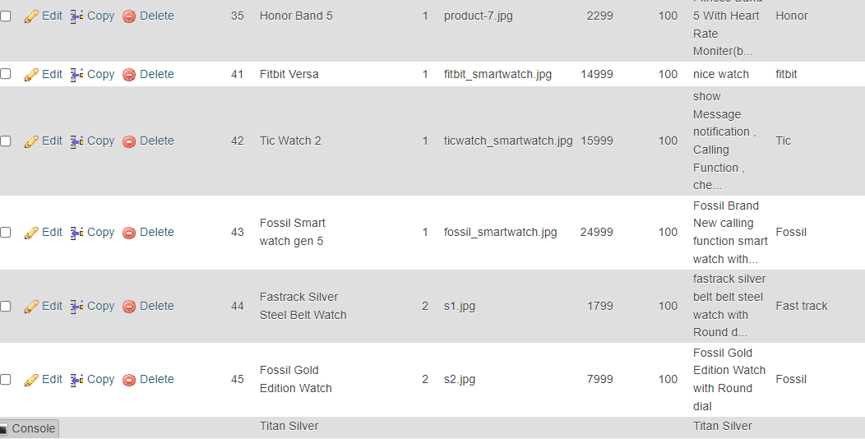

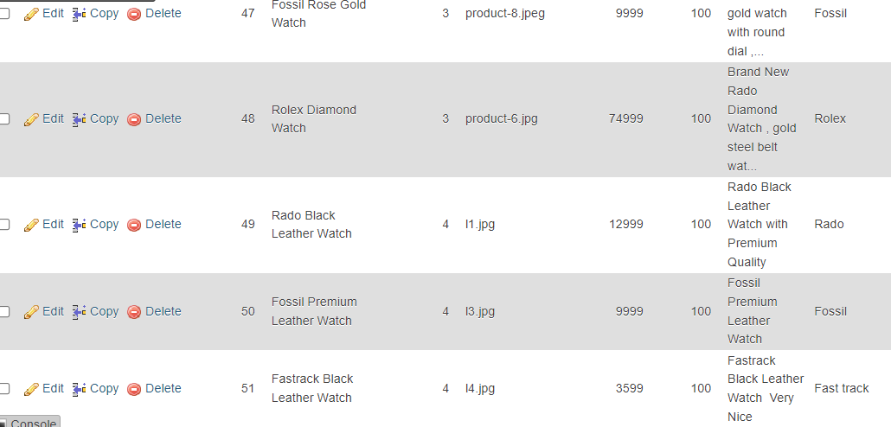

* **User\_Master:**

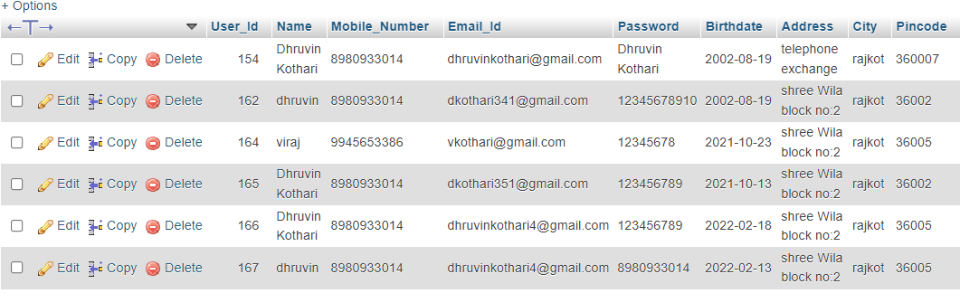

**(9) SUMMARY & CONCLUSION**

* E-Commerce is a great way for business and consumers

To interact internationally.

* The future of E-commerce will drastically progress over the years as the amount of internet users among businesses and consumers grows drastically every year.

* Developing an Website is not an easy task after all, so we have many different problems that occur during the project.
* Most importantly we learned many things during this project. Among which the most important was to learn advanced language like php. Thus this project helped us in many ways.
* Our have a three types of payment method.

1. Cash On Delivery
2. Credit Card
3. Debit Card

* **REFERENCE :-**

Website: [www.w3schools.com](http://www.w3schools.com)